1st Streatham Common Scout Group

Unreliable Memoirs from the 1960s

  - Background
The Scout Association was founded in 1908 by Sir Robert Baden-Powell after the first experimental Scout camp on Brownsea Island in August 1907. The first scout troops were founded that year. Over 90 troops claim to have been founded then including the 1st Streatham Common (1SC), which was the first troop in Streatham, rumoured to be in July 1908.
When I joined in the 1960s, the 1SC scout hut was, and still is, located on a corner piece of land in Estreham Road, bounded at the back by what Google Maps claims is Eucalyptus Mews. It is understood that an earlier hut was further up Estreham Road, but when the council houses were built, the corner piece of land was vested by the council to the troop, and a new hut built, probably in the late 40s/early 50s. A more up-to-date hut was built in the 2000s, mainly at the instigation of, and hard work by, Slim and Dulcie Foan, and this can be viewed on Google Maps.
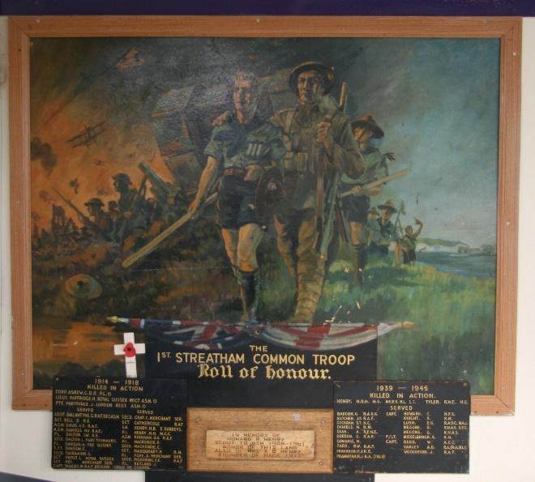
The 1960s Scout Hut was on the left-hand side of the land on entry from the road, leaving a reasonable area for drying out equipment and tents, or for playing the scout version of Volleyball to the right-hand side, into the corner of the triangle. A large Plane tree was present to the left near the entrance gate, either on the scout hut land, or next door (this has since been removed according to the satellite view on Google Maps, as have the 2 Sycamores on the right of the gateway).
The old hut was normally entered via a portal on the RHS at the back, leading to a perpendicular passageway to the main hut on the left and to a small scouter’s room on the right. A carved wooden Pillar on the portal was carved with “July 1908”. The main hut was about 40’ long, to the left of the entry door, and about 15’ wide in front of you. On the far wall to the left was the main equipment entrance double doors, to the left of some lockable equipment boxes, one per group (cubs, scouts, seniors etc), each about 2’6” high and 3’ depth from the back wall. Above these was the Group Roll of Honour, (see right), which was normally covered by curtains, comprising a large painting of some scouts and some WW1 soldiers, plus the roll of the fallen and those who served from the two world wars. This has been preserved in the new hut.
On the far wall from the entry door, and to the left, two thirds of the way along was the Union Flag attachment (the flag hung from a beam when unfurled), followed by a large hatch into the kitchen and a door into a short passageway with a toilet to the left and the kitchen to the right. The kitchen was small and could only hold a couple of people, (more if they were good friends!), but had the usual sink, cooker, kettle, lift-up table etc. The kitchen extension was built by John Bowden, John Heather, John Gilchrist et al (possibly including other people not called John!) out of Breeze Block whilst they were Senior/Rover scouts.
Above the hall were timber beams used for scouting games involving hanging around and storage of canoes of which we had three or four doubles, plus a locked attic area for the storage of group camping equipment, tents etc. The walls of the hut were believed to be made of Asbestos sheeting, (which was not seen as a problem in those days), and occasionally an over-active game resulted in a hole in the wall. Nobody seems to have died of asbestos poisoning as far as we can tell.
To the right of the portal was another structure containing the scouter’s room, accessible from the passageway, (this was about 5’ square), and a separate room, slightly larger and accessible from the outside via a separate door, which was the Senior’s and Rover’s den, later to become the Venture Scout den. A door connected the two which was usually locked.
In the early sixties, when I first joined the scouts (probably late 1962 aged 10½) after an abortive visit to a cub meeting with Steven Oliver which left me singularly unimpressed, there was one cub pack (meeting on a Wednesday, although at one earlier time there seems to have been a second pack meeting on another night), a scout troop (meeting on a Thursday evening from 7:30) and a group of Senior/Rover scouts who met on a Friday evening (plus a Social/Games night on Tuesday). Cubs at the time were from age 8 until 11, Scouts from 11 to 15, Senior Scouts from 15 to 17 and Rover Scouts from 17 to 19.
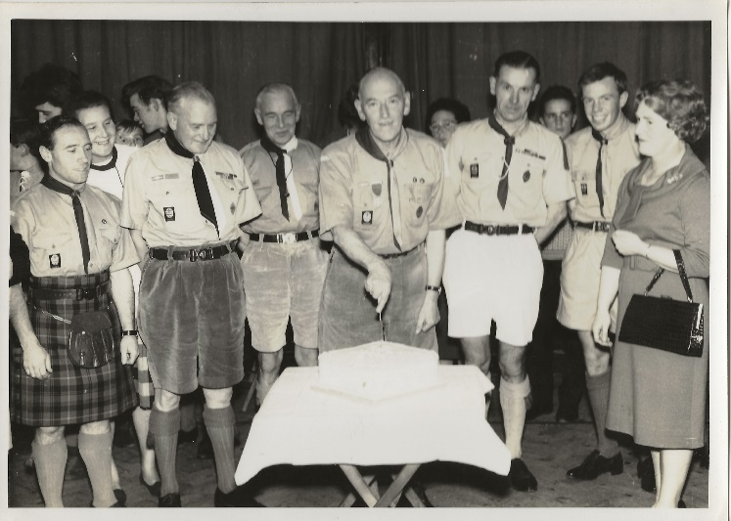
At the time of my joining, the Group Scout Master, GSM, was Stan Francome, and apparently, he had been from the 1940s and 50s. He later retired and was replaced by Ian Giles, noted for a fine Scottish lilt and who went onto greater things as District Commissioner (DC) or even County Commissioner (CC). The cub pack was led by Akela, who was Lew Grey (otherwise known detrimentally as Wally), plus two female assistants, Shere Khan and possibly Baloo? I have no idea who they were in real life! The photo (right) shows a group event, possibly Stan’s retirement as GSM, with from left to right Ian Giles (Stan’s successor as GSM), Bill Harris (the then DC), 'Pip' Rands (ADC Scouts), Stan Frankham (GSM), Edgar Chambers (SM), John Heather (ASSM) and Paul Tinwell's mother – Mrs Beeby – who we believe may have been Parent Association chair.
  - 1SC Scouting in the Sixties
I joined the 1st Streatham Common scout troop as a callow, weedy 10-year-old child, along with my best friend, Gary Ellis, who lived opposite me in Pathfield Road, 5 minutes’ walk from the scout hut. I probably left 4 years later to join the Senior Scouts as a callow, weedy 14-year-old youth! Tall and scrawny was how somebody described me at university and that description probably fitted earlier as well. Gary left the troop after a less than a year (for reasons I won’t go into) and I lost contact with him after he had moved away from Streatham a couple of years after that, only to meet him again 40 years later and to find he only lived 2 miles up the road from me in darkest Hampshire!
Scout Leaders
It is believed that one of the early scout masters was a Mr Howard R Henry, who was reputed to be one of the original scouts when the Troop was started. He is listed in the central panel of the Roll of Honour, as being Scout to GSM, 1908 – 1961 with probably his wife starting the Cub Pack in 1917. Interestingly, an H R H Henry is shown as having been killed in WW2 (maybe their son?)
The Scout Master (SM) when I joined was Edgar (Eddie) Chambers – Richards Chambers’ father. Tall, Brylcreemed, with to me a bit of a military bearing, Eddie had the most incredible kneecaps, which he could move up and down at will, leading to great hilarity when we got a bit bored waiting for something to happen. As SM, he delegated a lot of the rest of the scout meetings to his Assistant Scout Masters (ASMs), who were John Gilchrist and probably Chris Weymouth (the name rings a bell anyway). Sometime later in my tenure, a Martin Wiles was the ASM at a couple of the later Summer Camps.
John Gilchrist left the troop after a couple of years to spend a year driving overland to Australia, with Eddie Whiston of the 31st Streatham by Land Rover. I don’t think they managed it (not surprising given the quality of vehicles in those days), and he later returned as ASM, possibly to take over the troop after I left. It is likely that Eddie left in 1964, and Ian Giles took over as SM for a short time, before becoming Group Scout Master, then moving into some District/County role, but my memory is a bit hazy and unclear regarding what happened after I left, which is interesting given that at some point I did some service with the Scouts as an assistant leader, necessary as part of my Queens Scout work, but I remember absolutely nothing about that time. Neither do I know what became of any of above leaders, apart from Richard’s father who died in 1981 shortly after having moved to Dent in the Yorkshire Dales. His wife, Connie, lived in Dent for many years and died in 2019.
Uniform
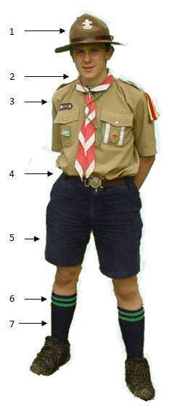
Uniform in those days was khaki shorts and scout shirt, leather belt, along with long khaki socks, shoes (no trainers in those days – I think we took plimsolls to scout night and got changed after parade) and a green beret, with possibly a sewed-on badge, although this changed at some point to a metal, gold coloured fleur-de-Lys. This was after the days of pointy, wide-brimmed hats although I think one Streatham troop still wore them – pretentious and showing off in my opinion – had to be the 3rd Streatham!
The scout shirt was short sleeved and contained large chest pockets, for storing stuff and for displays of rank badges. The uniform was embellished with a scarf and woggle (freshly ironed every week obviously – some hope!) around the neck, garter tabs (green cotton flashes on elastic to keep them and the socks up) and a patrol flash - two bits of folded woven cotton material (about 12” long and 1” wide, doubled over) of the same or different colours, attached with a small safety pin, so that the outer colour largely hid the inner one. The patrol flash was attached to the left shoulder of the shirt, hanging down about 6”. The figure to the right whilst not a UK scout, and with different colours shows the general layout of the uniform. The figure below is probably a better example of the UK scout uniform as for uniform colour and the beret, which should be olive green.
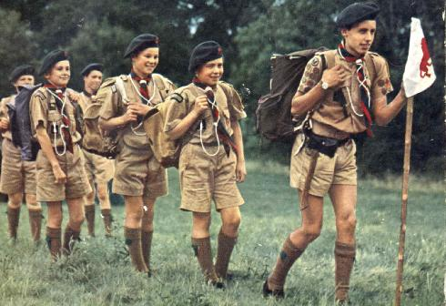
Ranks of Patrol Leader and Second were depicted by one or two white flashes on the left chest pocket. I believe some troops may have had a Troop Leader, with a third flash, but 1SC was never big enough or pretentious enough for that. A scout association badge was sewn on one of the chest pockets.
The 1SC scarf was in two colours, blue on the right and yellow to the left. A woggle “tied” the scarf in front of the top button of the shirt. Initially a simple leather circle, attached by a press stud, but as you stayed in the Scouts longer, you either made your own leather Turks Head woggle, or there was an official metal one later. Some pictures seem to show different coloured scarfs, which implies maybe there was a change at some point. Certain people also wore a white lanyard around their necks and looped a few times around the scarf before being attached to the belt. This could have indicated rank (Patrol Leader?) or some award, but I’m unsure what.
The Scout Cord, of which more later, was one of the highest awards to be gained in the scouts at that time, this being a thick green, braided, (like a ponytail), length of cord, with tassels on one end and a loop on the other. This circled the right shoulder, before going into the right top pocket, with the tassels then coming out and hanging loose (see leader in photo above). Proficiency badges were small cloth badges sewn on either sleeve dependent upon the type.
Scout Night
Scout Night was Thursday evening, starting at 19:30, and finishing around 21:00. Woe betide me if I arrived home after 21:30! Especially as the following day was a school day. This meant that I never saw Top of the Pops, neither did I ever see the original Avengers, the latter being a source of immense frustration (there was no videoing nor iPlayer in those days – if you missed it, you missed it! Probably got more chance of seeing it now on Dave!)
The evening commenced with a parade, with scouters lining up in front of the kitchen hatch, next to the flag, and scouts lining up against the opposite wall, Patrol Leaders to the right and in front, Seconds to the left, aligned with the other patrol members. Patrol Leaders and Seconds were allowed to wield a stave during the parade. The meeting started with unfurling of the flag, performed by each Patrol Leader in turn on a weekly basis, then came announcements, an outline of the nights program and any awards (conceivably and on reflection these were probably awarded at the close of the evening).
The evening consisted of Games, any work parties required (cleaning up equipment, preparing for camps etc.) and preparation for any upcoming Proficiency Badges etc. Scouts worked towards their “Second Class” badge, followed by “First Class” Badge, the former comprising a list of tasks such as recognising 6 common trees, whilst the latter required knowledge of 12 trees as well as 6 common birds as well as how to wield a Felling Axe, which I still do regularly now. No idea what other things were required to complete the badge, but doubtless they included a number of nights camping, making stuff such as camp equipment etc. as well as a hike of a certain distance (8 miles for Second Class being a number that springs to mind, possibly 15 miles with an overnight camp in the case of First Class).
Proficiency Badges
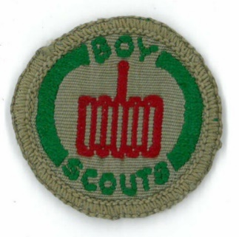
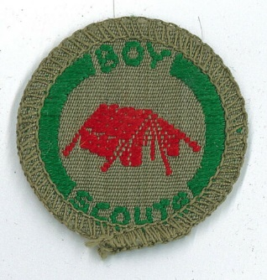
As well as the First- and Second-Class badges, which were organised and assessed by the troop’s scouters, scouts were expected to gain Proficiency Badges which were sewn mainly onto your right sleeve along with the First or Second Class badge. Proficiency badges came in different classes, some for outdoor activities, whilst others were for indoor activities. Each had a prescribed list of tasks which had to be completed. Badges tended to be signed off by an external examiner, either within the Scouting Movement or outside. For example, I gained the Interpreter Badge for passing O-Level French, signed for by my French Teacher at School. Proficiency badges each had a separate picture/icon on them showing the type of badge (see image right which is the Camper badge).
Some outdoor-type badges were awarded after successful attendance at a weekend camp, which was arranged and assessed by district personnel. The main ones of these were Camper (image of a Tent on the badge, see above) and Cook (Grill), which were done at the same time, Pioneer (Clove Hitch around a spar) and Backwoodsman (Open Fire – see below). Prominent amongst the leaders in charge of these badge weekends were Roy Hunt (ADC) and Keith Merrall. Roy Hunt I knew from outside Scouting as we often took the same train from Streatham Common station to London Bridge, me for school, him for work.
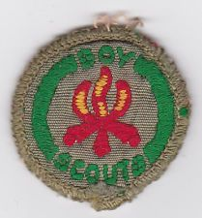
The Scout Cord was awarded for completing the First-Class badge plus gaining of 6 proficiency badges. Probably some had to be of the “outdoor” variety. At the time, this was the highest award available within the scout troop.
Backwoodsman Badge
Here are some notes on the Backwoodsman badge which I found online, and give an indication of the requirements:
The Backwoodsman Badge was worn on the Right arm in between the shoulder and elbow.
A scout could not gain any more than 6 proficiency badges before gaining a First Class scout badge.
To earn this badge a scout must do the following:
(1) Make a satisfactory shelter for two people, using natural materials, and sleep in it, alone or with another Scout, for at least one night.
(2) Skin and cook (without utensils) a rabbit, or cook in clay a bird at least as large as a pigeon, or clean and cook a fresh ﬁsh without utensils.
(3) Demonstrate three of the following:
(a) Improvised methods of moving injured persons having due regard to their safety and comfort.
(b) Climbing a tree to a height of at least 20 feet from the ground and lashing on the foundation spars of a look-out post.
(c) Rowing a boat, paddling a canoe, or poling a punt for at least half a mile.
(d) The construction of a sundial, or a gadget to ﬁnd the True North.
(e) Any method of purifying contaminated water and of straining muddy water.
Patrols
When I first joined the 1SC, the patrols were Eagles, Ravens and Peewits, with probably around 15-18 scouts comprising 5 or 6 per patrol. The patrol flashes were something like:
- Ravens: All Black.
- Eagles: Green outside Black.
- Peewits: Green outside White.
On first joining, the Patrol Leader (PL) of Ravens (my first patrol) was Bob Stent, whilst the Eagles Patrol Leader was John deLiege. John left soon after I joined, and Bob a year or so after that. No idea who was the PL of Peewits.
I suspect the troop reduced in size for a time, and Peewits were disbanded. A couple of years later when the troop numbers increased and a third patrol was reinstated, Owls was chosen instead. I was going to say that I had no idea what colour the Owls patrol flash was, but then Light Blue popped into my head. I really should remember as this was latterly my patrol and I think I was probably its first PL.
Games
Scout night games tended to be of the fairly active and violent variety, with a few quieter ones for cooling down after some of the more physical games. Some which spring to mind include:
- British Bulldog. Classic game where one patrol holds the middle ground of the scout hut, whilst the other patrol(s) are at one end or the other and try to get to the other end, without being caught (and lifted off the ground).
- Roll/Bowl the Barrel (or other less salubrious names of which “Jump to my Knackers” is the most prevalent). This involved one patrol making like a one-line scrum, using typically the newest or weakest scout as a cushion against the boxes at the end of the hall, and each other patrol member bending over into the next persons backside. The other patrol had to take a run up then launch themselves onto the line (as far up as possible), until all patrol members were being supported by the scrum. The winner was the receiving team if one of the jumpers touched the ground, or the jumping team if (part of) the scrum collapsed.
- “Pick up the keys” ??? (Can’t remember what this was called). This, and the next game were for winding down after strenuous games, possibly at the end of the evening. One person is blindfolded and put in an upright chair under which are placed a bunch of keys. Other people attempt, singly in turn, to quietly walk up to the chair and remove the keys without making a noise and being pointed at by the blindfolded person.
- Kim’s Game. Classic memory game with a tray of objects which were viewed for one minute or so, then the contents needed to be remembered after the tray was covered or taken away.
- Scouts’ variant of Volleyball. This game was played in an area outside, with a standard Volleyball type net, and a pitch marked by lines or fences or whatever. Rules were similar to Volleyball except that you caught the ball and then threw it to another team member (up to 3 times) or over the net to try and get it to hit the opposition area without hitting the lines/walls.
- Scouts’ variant of Handball. Yet again a variation on the game played on the continent (actually on reflection totally different!), since it was played inside a Scout Hut (which were all non-standard sizes) with a ball of football size and weight, which was propelled, dribbled or passed along the floor to another team member using a hand – no feet allowed! Goals were again random sizes dependent upon what was available, and had a goalkeeper, who could roll around the floor if required. In the 1SC case, these were benches, whilst others had 5-a-side goals or proper handball goals.
- Wide Games. Wide Games were external events, played in the countryside, either as part of a summer/weekend camp, a complete troop night, or an organised District event, even at times with the Girl Guides/Rangers. Typically, they were played in teams (patrols usually) and had an objective, the main one probably being not to lose anyone! Real objectives could include locating another teams’ HQs and stealing a flag or finding a common location first. Thunderflashes/Bangers seemed to be an integral part of these games, which would doubtless not be allowed these days!
- Night Hikes. Night Hikes were an excuse to stay up all night (why that would be attractive is beyond me now!) and involved a car/mini-bus or train ride to a location, then a walk of a few miles, at the end of which (hopefully) were hot refreshments/breakfast rolls, and then home by getting up time.
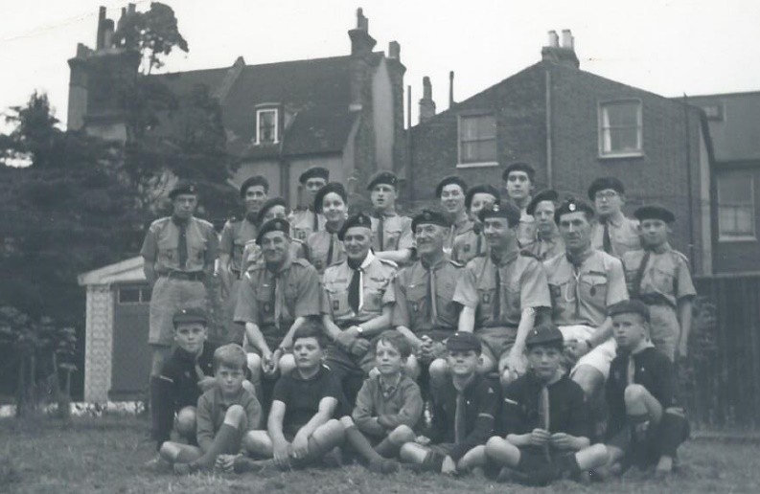
Troop Personnel
The following people were scouts during my tenure, although this is a fairly small number considering the turnover of people moving up, moving on etc over a four-year period. Just shows how hazy is my memory for people! The photo shows a selection of Cubs, Scouts and Senior Scouts, plus scouters from all groups. The middle row of scouters contains Lew Gray (CSM), Bill Harris (DC), Stan Francombe (GSM), Dave Kincombe (SSM) and Eddie Chambers (SM), with John Heather (ASM) on the left of the back row.
- John deLiege. Patrol Leader of the Eagles patrol when I joined and probably 4 years older than me. Left within a few weeks of my joining to join the Senior Scouts.
- Bob Stent. Patrol Leader of the Ravens patrol and my first patrol leader. He left to join the seniors about 6 months after I joined.
- Paul Tinwell. Paul took over as PL of the Ravens patrol and hence became my next PL. Paul was a major influence on me in scouting over the next 5 or 6 years, and was to my knowledge the only leader of a 1SC team to actually win anything (District Camping competition in 1965)! Paul was a superb mechanic and kept John Bowden’s wreck of a car and the Venture Unit minibus running long after their obsolescence had expired.
- Ian Cormack. I look on Ian Cormack as the enforcer and hard-man of the troop, an accolade which is probably a terrible slur on him, and I am sure he is now a really nice guy. I was terrified of him when joining, but over time he became a friend and definitely someone to have on your side in a crisis. Apparently, he also had 2 other brothers in the troop at various times, although I don’t recall them.
- Ian Janes. One part of the “Terrible Twins”, along with Julian Ben-David. It would be terribly unfair, but probably true to blame all unacceptable behaviour onto them. But great guys if you were part of their clique, into which they seemed to accept me mainly as a butt of their jokes!
- Julian Ben-David. The other of the Terrible Twins (see Ian Janes above). Ian and Julian communicated in their own strange language a lot of the time, especially at summer camp, unintelligible to anyone else, but which seemed to comprise of “Stronto”, “Ollingsgate” and “Parsbury” - the mind boggles!
- Keith Major. Keith was the most memorable of the group of scouts who were older than me by a year or so, but not yet senior and in the PL positions. He was around for much of my time in the scouts, until he reached leaving age, when he may have gone into the seniors, but I can find no trace of him there.
- Dilip Patel. Dilip was an Asian guy with a pronounced limp, who was in the troop for a couple of years.
- Gary Ellis. Gary lived directly opposite me in Pathfield Road, and we joined the 1SC together. He left the scouts about a year later after the first Summer Camp. He now lives a couple of miles up the road from me in Hampshire, is big in the Masons, and plays a lot of Bridge (but he’s not as good as me! - although he would argue otherwise).
- Steven Oliver. Steven was my first friend when we moved to Streatham aged 10 because he was allocated at Granton Primary School to be a mentor on my first day since he also lived in Pathfield Road, me at 17 and him at 77, which the form teacher thought was synergy or karma or something. Steven was a few months younger than me and joined a few months later from the cubs. We definitely went on a couple of district badge camping weekends together although he seems to have drifted off after a couple of years.
- Alan Drewett. Alan joined around the same time as me, but was always in a different patrol. The only noteworthy event I remember is when he got a fishing hook stuck in his hand at our first Summer Camp and had to have it removed in hospital.
- Chris Kilcoyne. Chris was a couple of years younger than me and joined with another boy named Chris, but I’ve no idea what his surname was. Chris was a PL on my last Summer Camp.
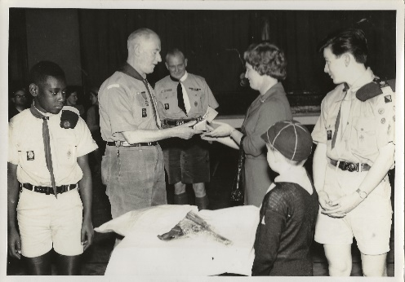
- “Squashie”. Squashie was a great guy, a lumbering Black gentle giant, and friend with whom I did my Second Class Hike (probably he dragged/carried me around all 8 miles). Don’t ask me what his real name was, he introduced himself and was only ever known as “Squashie”. Despite all the talk nowadays about racial prejudice back in the sixties, he never suffered any that I am aware of in the troop. He was a great one for his comforts at camp and would spend hours making his own kitchen campfire seats, whilst the rest of us slobbed around in the mud.
- Philip Sobers. John Bowden believed he was a nephew of the great Garfield Sobers (see photo right, alongside Richard Chambers).
- Stephen Dare??? Just a name and that may not even have been correct.
Troop Highlights
It would be true to say that during my time, the 1SC did not excel at very much on the District program, mainly because it was only a small troop in terms of numbers. I recall one District Sports day, when I was the only 1SC person to turn up (Scouts or Leaders)! However, our claim to fame is that on one occasion (probably in 1966) we did win the District Camping Competition, obviously to the chagrin of the other larger, more elitist Troops in the District. For some reason, either by accident or design, we entered a strong team (the “dream” team) with Paul Tinwell as Patrol Leader and Keith Major and myself as “Seconds” and we nailed it.
  - Summer Camps with the Scouts
General
Summer camp was the major annual activity of the troop. This was a two-week camp, typically in July (during which my parents always seemed to go away without me, so I missed out on holidays). I seem to remember that at least at the beginning the cost was £10, which was not bad for a fortnights board and lodging – even in a tent! Weekend or bank holiday camps at places like Downe or Frylands Woods, or the district badge camps, were mainly run by the ASMs, but Eddie Chambers always attended the Summer Camp, as did his wife Connie, who acted as First Aider and general shoulder to cry on.
We normally travelled to the campsite in a borrowed lorry, with all tents and equipment, personal rucksacks and scouts in the back of the lorry in different states of organisation or jumble. There were no seat belts in the back and sometimes not even benches so the concept of “elf and safety” didn’t really exist. Usually, the back cover of the lorry was left open for fresh air and we leaned and waved out the back (two fingered salute!) to passing/following cars. However, we always made it safely. Travel was always in full uniform, presumably to impress the natives.
The campsite was normally a farmer’s field which had been borrowed (by prior arrangement) from the farmer. Normally relations were good, although the odd complaint may have been received. I have no idea how much if anything was paid to the farmer. This was a different time when less people travelled or expected to camp on private land.
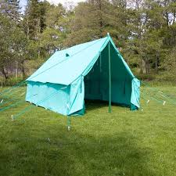
As soon as we arrived and emptied the van, we changed out of uniform, and donned plimsolls with no socks, a form of footwear which we kept for the next 2 weeks, unless we went out anywhere in uniform. Wellingtons were a “No-No”, whilst socks would have got wet and given us colds/flu/pneumonia. I must say we were all fairly healthy on it.
Each patrol had their own Patrol tent, which were usually Blacks ‘Nigers’, which held up to 6 or 8 scouts and kit. Each had a separate, heavy duty groundsheet, 2” thick upright and ridge poles and such esoteric things as “Dollies”, Storm Guys, Sod Cloths, Brailing Pegs and Tapes etc. The tent was made of heavy-duty canvas, with no flysheet, and apparently if you touched the inside of the tent whilst it was raining, it would leak until the sun came out and dried the material out. I was never convinced about that warning. On my first Summer Camp, I think one patrol had a “Storm Haven” tent instead. We also had a “Cromwell” tent at one time, which I seem to remember had metal poles to make a frame for the tent, rather than just poles.
The Quartermaster’s tent was originally a traditional Scout/Army Bell tent, from which each patrol drew their rations for each meal which had to be cooked by the patrol over an open fire. This was later replaced by the Cromwell, since the Bell tent had probably reached its sell by date. Each patrol also had a kitchen shelter, made from a tarpaulin plus surplus tent poles at the corners, under which you could shelter from rain (which seemed to be endless) and cook and eat meals. All meals were taken with the presence of a lucky scout leader, who had to share our humble (burnt / undercooked) fare. Skills soon learned included fire-lighting (with matches - not two boy scouts!), how to tell a boiling billycan of water by touching the side with a stick, making tea in a Billy, etc., etc. Given that all pots were cooked on an open fire, a lot of Brillo pads were consumed with the washing up.
One of the first tasks after arrival and getting changed out of uniform was digging the latrine pits, deep and wide enough for the whole 2-week period. This seemed to be one of the more popular tasks for some people, possibly to avoid erecting tents and kitchen shelters. Personally, I never saw the attraction of digging holes for toilets!
The next two weeks were mainly a round of Reveille, Breakfast, Games or activities, Lunch, Free time, more Games, Dinner and on some nights a campfire or a wide-game in the dark. If the weather was good (it did happen occasionally), the brailings were rolled up and tied to air out the tents.
Islip (1963)
My first Summer Camp was at Islip, just off the A34 near Oxford. Close to the campsite was a dam which was great for wide/night games. Paul Tinwell was my Patrol Leader. Events of note include:
- A day trip to the Morris factory at Cowley, my main memories are of fire and sparks, much like the Orc factories in Isengard in the Lord of the Rings. I expect it wasn’t quite that bad in reality!
- Alan Drewett managed to get a fishing hook stuck in his palm and needed to go to Hospital for an amputation (of the hook!)
- My best friend, Gary Ellis, left the camp a couple of days early for personal reasons.
- The Dam, which was great for wide games, and amazingly, we managed not to drown anyone. Looking on Google Maps (satellite view) near Islip, there is a substantial dam shown on the “New River Ray” beside fields, and this looks like the exact location.
Isfield (1964)
I literally can’t remember anything about this camp, which was either this year or the next, so obviously nothing memorable happened. I may even have made Isfield up, but I know it was a similar name to Islip and Uckfield, and maybe Isfield (which is close to Uckfield) was the same camp, in which case I have no idea where this year’s camp was held. Maybe someone else can remember.
Uckfield (1965)
The next Summer Camp was to Uckfield (or maybe it was the previous year). The only events of note in my memory comprise a day out to the Seaside and a fun fair – probably Eastbourne - and having my first (and last) full cigarette (supplied by the terrible twins Ian Janes and Julian Ben-David) after which I was sick as a dog and have never been inclined to imbibe since. This was the main year of the terrible twins, who were possibly Patrol Leaders (along with Paul Tinwell), although who would trust youngsters with them is beyond me. I would imagine Keith Major would have been a Patrol Leader as well.
Islip (1966)
World Cup year, so after the final, and probably late August because one of the ASMs (Martin Wiles) went around shouting that we had won a final test against the Windies at the Oval, which finished on 21 August (we lost the series 3-1)! We visited the same campsite as in 1963, although a different field, much closer to the Dam, so the usual round of night games involving the Dam! I was probably senior scout at the camp and a Patrol Leader. One of the other Patrol Leaders was Chris Kilcoyne, whom I considered way too inexperienced, but beggars can’t be choosers. I believe that a couple of Senior Scouts visited the camp for a few days and doubtless bullied the scouts during the wide games around the dam.
  - Senior Scouts
Joining the Senior Scouts
I partly left the scout troop to join the 1SC Senior Scouts towards the end of 1966, at the tender age of around 14½, taking part in both meetings for a few months until my formal investiture into the Seniors. The Senior Scout Leader was Dave Kingcombe (who had previously been an ASM with the scout troop), with ASMs of John Bowden and John Heather. The main meeting night was Friday from 19:30 to around 21:30, after which most people repaired to the Railway Tavern at the far end of Estreham Road, which had last orders of 23:00. Obviously, I was way too young to drink alcohol in said hostelry, although I may have imbibed the odd lemonade or two as I was old enough to enter pubs with an adult. There was a second social/games night on a Tuesday evening, which was more informal, no uniforms, which were required on Fridays. Again, suitable refreshment was sought after such a hectic evening.
The Senior Scout uniform was essentially a scout uniform (presumably to reduce cost), but with Maroon epaulettes, and garter tabs (but much fancier), and similarly coloured beret and optional long trousers. The main meeting night was a similar collection of formal parade and flag unfurling, followed by badge work, games such as handball and other social activities. Tuesday night was informal, playing games such as Table Tennis (Whiff Whaff) and I think we had a small snooker table at one point. Any work on equipment which needed doing was also done then, which mainly comprised repairing the canoes, which were stored in the rafters. We rarely seemed to actually go canoeing, but we spent a long time repairing the wooden frames and varnishing them, followed by repairing or replacing the rubberised canvas coverings. This was before the days of glass fibre canoes!
During the game’s night, tea and coffee were available (normally at around 21:00), along with sometimes biscuits, or even better, reject Cadbury’s Bar-Sixes obtained from work by John Bowden, and supplied for a small cost. John worked for Pascalls at this time who were owned by Cadbury. Bar-Six, for those of you who don’t remember or are too young, was Cadbury’s alternative to Kit-Kat, with 6 shorter fingers per pack. The rejects were often either all chocolate (my preference) or the wafer was not in the middle of the chocolate, definitely better than Kit-Kat cos it was Cadbury’s Chocolate!
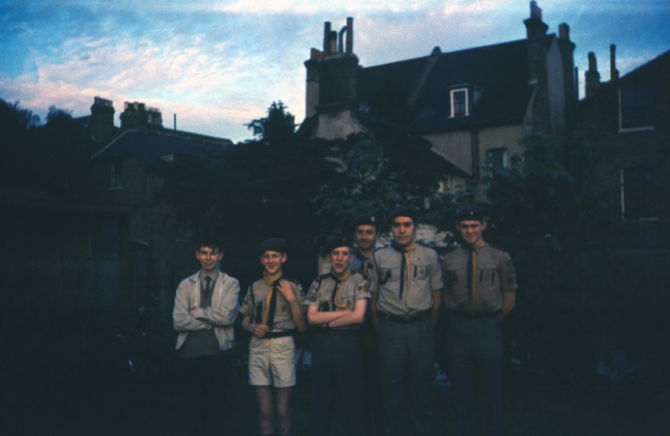
The photo (right) shows from the right, Bob Stent, John deLiege, Dave Kingcombe (SSM), Paul Tinwell and Ian Janes, plus on the left an unknown person, probably taken in the Scout Hut grounds. This is a Senior Scout meeting (see claret epaulettes), with Ian Janes still in Scout uniform (and scarf the wrong way around – what a surprise!)
The Senior Troop had no transport of its own, but we got by with the Scouters’ cars (Dave K had an A40, John B an ancient Standard 8 and John H a fairly new Austin 1100). When we were not in the main hall, the Seniors and Rovers had a separate hut, attached to the Scouters room and accessible from outside the main hall entrance.
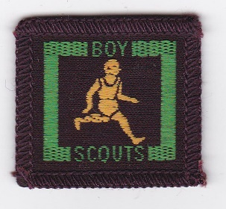
The Senior Scouts also had proficiency badges to be gained, which were maroon and square (as opposed to the round, khaki Scout badges). Although requiring more complex tasks to be performed, senior badges similar to the equivalent scout badges were on offer (e.g. Senior Pioneer). The ultimate award for senior scouts was the Queen’s Scout award, which is still, I believe, the top award within scouting and I understand is similar in complexity and worth to the DoE Gold Award.
As well as indoor activities, the seniors had a much larger range of outdoor activities. (At that time, scouts tended to go to camp just to camp, not as a way of doing something else). Senior activities which I partook included amongst others climbing at Harrison’s Rocks, canoeing at Marlow and caving in the Mendips.)
Summer Camp 1967 – Switzerland and France
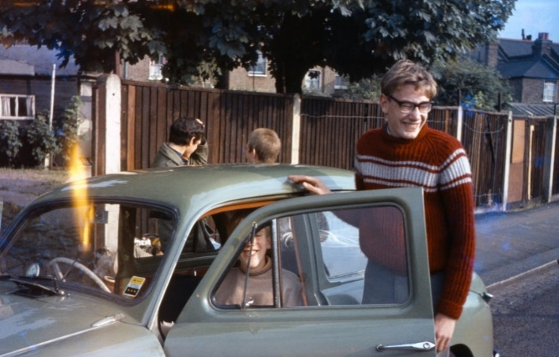
My first (and only) Senior Summer Camp in 1967 was to Switzerland for a week and then the second week in Le Lavendou in the South of France for a bit of R&R. In Switzerland, we were camped just outside of the village of Evolene, halfway up a mountain in the canton of Valais. We took two cars, John Bowden in his (not so) trusty Standard 8 and John Heather with his 1100 (see photos below). Given we had about 2000 miles to travel and the state of British made vehicles in those days, the trip was fraught with vehicular problems.
Left is a photo of John Bowden’s famous Standard 8, so this may be just before leaving on Senior Scout Summer Camp 1967, with Paul Tinwell riding Shotgun. Note the rather sexy pullover, knitted by my mother, which will be seen again in other photos. If this was just before leaving on Summer Camp, the car didn’t make it as far as Dover before a wheel bearing seized. Luckily, we had Paul Tinwell on board to fix it, so the delay was only 24 hours or so. The photo appears top have been taken outside the Scout Hall in Estreham Road.
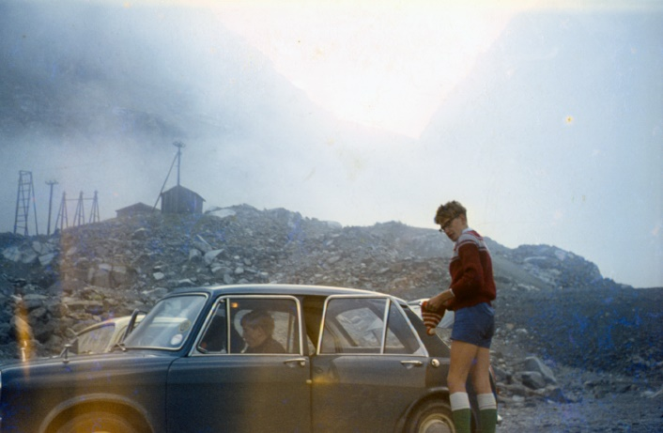
Another photo, this time John Heather’s 1100, again, with Paul in the front passenger seat, but at least this had four doors making getting in and out of the back easier. I believe that both cars were full, meaning there was either 7 or 8 people on the camp. Apart from the two drivers and Paul Tinwell and myself as in the pictures, Ian and Julian, the terrible twins, were also probably there, the others being unknown.
Even John H’s car was not immune to the car jinx of that trip, breaking down somewhere in France or Italy. My main recollection of the journey is hitch-hiking in Switzerland by myself to reach the campsite after John Heather’s car had broken down. One of the lifts I got was in a Peugeot 504, which at the time was a brand-new model, considered the “Rolls Royce” of French automotive technology, Peugeot being the top-end of French cars at the time. It was the most luxurious car I had been in at the time. Fortunately, O-Level French got me where I wanted to go. Once again, Health and Safety seems to have taken a back seat, and my mother would probably have gone spare if she knew that her 16-year-old little darling was hitch hiking alone around Europe – different times indeed!
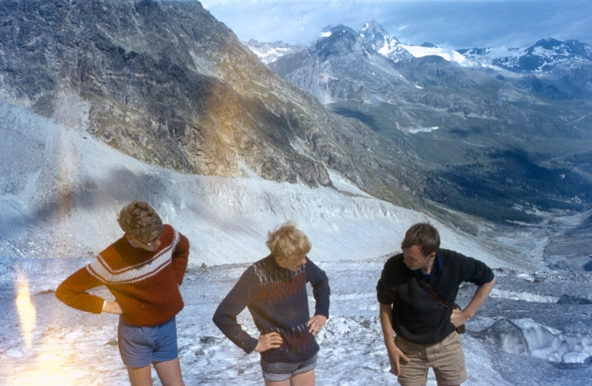
When we finally all arrived in Switzerland and pitched tents, we repaired to the local café/bar for the rest of the week. About the only British song on the Jukebox was Procol Harem’s “Whiter Shade of Pale”, so we played that incessantly all week, which must have made the locals pig-sick of it. Apart from catching frogs in the campsite field and racing these, not much of note happened that week apart from the odd walk up a mountain. This photo shows the famous pullover, Paul Tinwell and John Heather somewhere up a Swiss mountain or (more likely) on a Swiss glacier and proves that we did do more strenuous activities!
We camped in small two-man tents, mainly bright orange Blacks Good Companions, triangular shaped tents with flysheets. Meals were mainly cooked on primus stoves as a group, from supplies purchased locally, with the very occasional meal out, which in Switzerland involved Raclette which John Bowden had had before and comprised melting your own cheese over a grill in the middle of the table, and consuming this with a very small baked potato and onion. Exotic fair indeed!
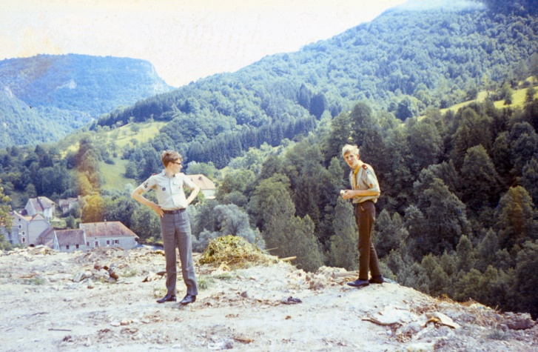
The photo on the right is myself and Paul Tinwell, probably in Switzerland given the scenery. Note the fact that we were wearing a scout uniform (Paul has Senior Scout Epaulettes on) and for me - not the famous pullover! So, it must have been some sort of special event in Switzerland during 1967. John Bowden believed that we should always travel in uniform and make a splash, so this may have been just as we were leaving the campsite for the drive down to Le Lavandou.
I believe that we went through the St Bernard Tunnel on the way down to the French coast, but Google Maps indicates that this would have required travelling through Northern Italy which I’m not sure about. It seemed to take a couple of days, whilst Google Maps shows about 7-8 hours travelling time. Obviously, cars have improved and so have roads, so maybe both are right.
After a week of sunning ourselves on the French Riviera, during which one of the highlights for me was buying crates of Peaches, and gorging ourselves on them, a luxury unheard of in more austere Britain, we made it back to Streatham relatively unscathed.
  - Post 1967
Scouting in the UK underwent a major review, known as the Advance Party Report, in 1967. The name of the organisation was changed to be ‘The Scout Association'. Major changes to the sections and their respective programmes were made - the youngest section were now Cub Scouts, Senior Scouts became Venture Scouts (for 16-20 year olds), and the Rover Scout section was disbanded.
The Scout Uniform was also changed - most notably with the inclusion of long trousers for the Scouts (previously they had been wearing knee-length shorts).
The 1SC Senior Scout Troop morphed into the Estreham Venture Scout Unit, but at that time we only had half a dozen members, so we merged with a number of other Senior Scout Troops into a single Unit. But that’s all for Part 2 of these unreliable memoirs!
  - Acknowledgements
- Photos courtesy of John Bowden et al (some also “borrowed” from the Reunion web-site).
- “75-Year-Old memories of time spent as a member of the 1st Streatham Common Scout Group”, recently published by Dave Brown.
  - David Webb Lockdown 2021…

